**Batch: B2 Roll No.: 16010121110**

**Experiment No. 06**

|  |
| --- |
| **TITLE: Demonstrate the File Uploading in PHP** |

**AIM:** To understand various file operations and file upload in PHP

**____________________________________________________________________**

**Expected Outcome of Experiment:** Process external files in PHP.

**________________________________________________________________**

**Books/ Journals/ Websites referred:**

**_____________________________________________________________________**

**Problem Statement:**

**Write a PHP program to upload a file in a folder** **and show its name**

**Description of the application implemented with output**:

<html>

<form action="upload.php" method="post" enctype="multipart/form-data" >

<input type="file" name="uploadedFile">

<input type="submit" name="submit">

<input type="text" id="email" name="emailInput"><br><br>

</form>

</html>

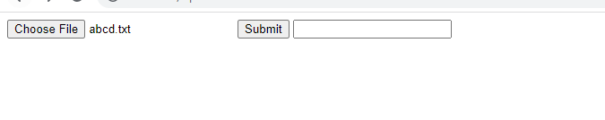

<?php

echo 'Hello';

$filename = $_FILES['uploadedFile']['name'];

echo "\n The file you uploaded is named ".$filename;

$filetype = $_FILES['uploadedFile']['type'];

echo "\n The file you uploaded is of the type ".$filetype;

?>

image

**PHP Basic Concepts Learned With Syntax**

$_FILES array

$_FILES[uploaded file html input name] is used to access the file. The file has the following parameters example

1. Name
2. type

These can be used to access the file information

**Post Lab Questions:**

**1. Perform following file operations with respect to problem statement/application:**

Open, read and write with various modes, append, delete and downloading file.

**Answer: Code with output screenshots**

<?php

echo 'Hello';

$myfile = fopen("applications.html", "r") or die("Unable to open file!");

echo fread($myfile,filesize("applications.html"));

fclose($myfile);

?>

